caB2B Web Application Architecture

Document Change History

Version | Date | Contributor | Description
V1.0 | January 23, 2009 | Washington University/Persistent Systems Limited | First Draft
V1.0 | March 2, 2009 | Washington University/Persistent Systems Limited | Addressed review comments
V1.0 | March 2, 2009 | NCICB | Abstracted to a higher level for LS CAT presentation

March 2, 2009

Introduction
The caB2B web application is a version of caB2B that is geared towards ease-of-use and targets users who do not have detailed knowledge of the underlying data models for caBIG applications. It will expose a subset of caB2B features via a web interface, as opposed to the present caB2B application, which is a thick client-server application where client is a desktop application implemented in Java Swing. The underlying caB2B server application will service both the caB2B desktop client and the web application.

Why a Web Application?
Although caB2B is a very powerful application, it has limitations in that it is a thick client, which requires setup and configuration on user machines. Also, it may require a slightly different setup process on differing architectures. Besides this, potential caB2B users need to be acquainted with certain technical caGrid information and terminologies in order to use the application.
The caB2B web application will help in accessing data from caGrid services, acting as a single access point for less sophisticated users. It will be designed as an extremely user friendly web interface that will help end users to query any available caGrid service, simplifying the grid terminologies and eliminating the model-centric view. A user with little or no knowledge of the caGrid should be able to use the application easily.

Architectural Principles
Based on the requirement of the caB2B web application we will be using the Struts framework which suits and satisfies our underlying needs as follows.
- We can reuse caB2B Admin structure and code based on Struts framework, helping us reduce our timeline for development.
- Struts is more widely used and supported than any other framework for J2EE enterprise web applications
- Struts provides all the features which are needed by our application and is also extensible.
- Learning and expertise other frameworks (like spring) which may provide same functionalities and has more features will take more time.
The caB2B web application will be based on the MVC design pattern, as shown below. For caB2B, the View layer includes client side view technologies, including HTML, CSS and JavaScript. For, dynamic generation of view components, we will be using JSP templates. The view layer, will not include any business logic or control, which is instead hosted in the Controller and/or Model layers. This will maintain loose coupling between different layers and ensure the application is more modular and more maintainable.
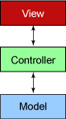

The controller layer will exist as a set of Struts Action classes. These Action classes will have code only for controlling the flow of the action, while the Model layer defines the business logic. Model layer will interact with the databases, grid services, and other data stores. Thus, the code for accessing, and manipulating the data layer will be encapsulated by the Model layer. Our project will have this code in the form of EJBs and BizLogic Java classes.

caB2B Web Application High Level Architecture

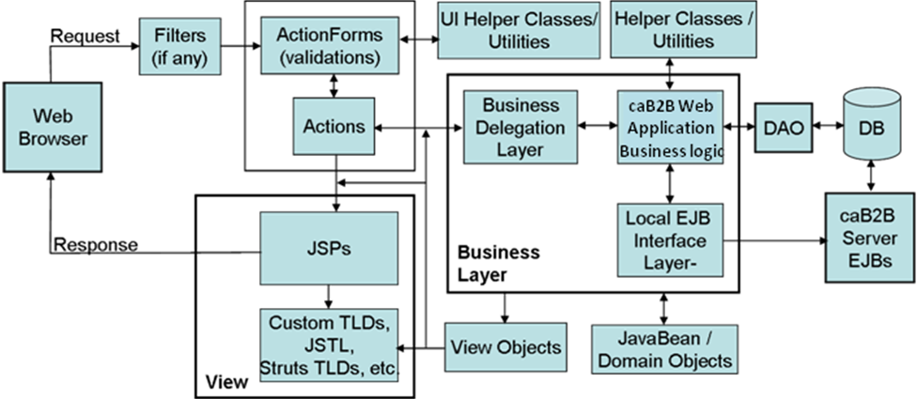
Figure 1 High Level Architecture

Several key things to note in the above architecture are:
- The Filters will ensure that only properly authenticated users (including “anonymous” logins) are able to access the system. These will interface with the caGrid authentication infrastructure
- All actions that require a query are directed through to the caB2B server EJBs to construct an appropriate DCQL query that is then sent to the Federated Query Processor (FQP) for execution. The parallel DAO to DB path is there to support future direct access to locally cached data.

Deployment
The caB2B web application will be deployed together with the caB2B server. The cab2bWebApp.war will be added to the cab2bServer.ear and will be deployed as a single deployable in JBoss server. This approach will enable us to reuse the working and tested modules from caB2B server.

We will also investigating a possible deployment scenario where the web application would be deployed separately from the caB2B server. This is not yet a validated requirement, but may impact the deployment in the future.

Risk Mitigation: Reliability
As described above, the caB2B server currently transforms all queries into DCQL which is sent to the FQP for execution. In caGrid 1.2, if a DCQL is constructed to search multiple grid service instances and any one of them fails, then no results are returned. Based on our conversations with the grid team, caGrid 1.3 will provide an additional API parameter to address this issue. We will investigate Federated Query Processor in caGrid 1.3 in our first iteration, independent of our development activities. Based on our findings, a decision will be made on integration of the caGrid 1.3 FQP into the application after iteration 1.

Risk Mitigation: Performance
As with reliability, the current behavior of caB2B server is to generate a single DCQL corresponding to the user’s search parameters and execute it using the caGrid Federated Query Processor. These are processed serially by the FQP, resulting in greatly decreased performance. To mitigate this, we will address situations where DCQL would be fired on multiple instances of the same application (e.g. on multiple instances of caTissue). These queries will be decomposed it into multiple DCQLs, one per instance. The newly generated DCQLs will be executed in parallel and results will be consolidated within caB2B rather than within the FQP.

Note that queries which get their results by joining data from different applications cannot be decomposed in this manner.

Authentication and Authorization
The caB2B web application will allow both authenticated and unauthenticated (anonymous) users access. Users who choose to not authenticate will be able to query only non-secure grid services, which currently represent all caBIG applications except caTissue. Users who wish to authenticate will provide a valid username and password combination for the production Dorian server. Once authenticated, the users grid credentials will be provided to any secure grid services that are queries.

The caB2B team will research the feasibility of supporting other Grid-recognized identity providers, such as the NCI LDAP. Part of this analysis will be to evaluate current caBIG-wide efforts to establish a common login/authentication mechanism.

Anticipated Technology Stack

Technology | Version | Comments
Java Platform | 1.5 Upgrade 14 | As proposed by caBIG
JBoss | 4.0.5 | As proposed by caBIG
J2EE | 1.4 | As proposed by caBIG
EJB | 2.1 | caB2B Server is using this version and we need to make local calls to caB2B server.
MySQL | 4.1 | caB2B uses dynamic extension in the backend. It is based on this MySQL version  We are researching the impact of an upgrade to 5.0.x
JDBC Driver for MySQL | 3.0.16 GA | caB2B uses dynamic extension in the backend. It is using this version of driver
IE Browser | 6, 7 | Supporting the most widely used browsers.
Firefox Browser | 2.0.0.3 | Supporting the most widely used browsers.
Safari | 3.1.1 | Supporting the most widely used browsers.
HTML | 4.0.1 | Supporting the most widely used browsers.
caGrid | 1.2 | Investigating the value/impact of upgrade to caGrid 1.3 (specifically FQP improvements)
Ant | 1.7.0 | Required for BDA tools
Globus toolkit | 4.0.3 | As proposed by caBIG
Apache Axis | 1.2RC2 | As used by caGrid
Hibernate | 3.0.2 | caB2B uses dynamic extension in the backend. It is based hibernate 3.0.2
JUnit | 3.8.1
Struts Framework | 1.3.5 | As proposed by caBIG

